Introduction:

Macromedia Flash is a program that creates interactive and animated media such as motion graphics, videos, presentations, and websites. We can understand animation as bringing a picture to life. An animation covers all changes that have a visual effect. A computer-based animation is an animation performed by a computer using graphical tools to provide visual effects.

Objectives:

- To animate something like picture or objects and bring it to life i.e. bouncing ball, walking man, flying bird, etc.
- To understand different use of different tools for different purpose.
- To be able to design different animations like bouncing ball.

Materials:

Software used: Macromedia Flash Professional 8.

Steps:
- Open macromedia flash, and new file using flash document.
- Use ‘line tool’ to create an image of a stair.
- Choose the color of your desire and fill the stairs using ‘paint bucket tool’.
- Add a keyframe and create motion tween.
- Use ‘Oval Tool’ to create a ball on the top of stairs.
- Use color of your desire for the ball and add a keyframe.
- Use ‘free transformation tool’ to select only the ball.
- Move the ball as required to create as if the ball is falling down the stairs bouncing downward.
- Add a keyframe every single time the ball is moved.
- Repeat the process for the number of frames you want to take until the last step of stairs.
- Enter control and Enter key to view the animation.
- Save the file.

Shortcut Keys:
- Ctrl + enter = Test movie.
- Ctrl + N = New File.
- Alt + W = Close.
- Ctrl + Z = Undo.

Windows in Macromedia Freehand MX.
- Properties: Contains the details of the document like size, background, framerates with access to edit them.
- Filters: Allow users to apply various filter effects to selected objects or text in their vector graphics.
- Parameters: Allow users to modify and fine tune the properties and attributes of selected objects or text within their vector graphics.
- Actions: Allows users to add interactivity to design elements. It allows for actions like hyperlinks, navigation, and multimedia control, enhancing the usability of designs for web and multimedia projects.
- Timeline: For managing frames.
- Tools: Contains many tools we can use for different purposes.
- Align: Allows users to precisely position and align selected objects within their design.
- Info: Provides detailed information about selected objects including their coordinates, dimensions, rotation angles and other properties.
- Transform: Allow users to perform transformations on selected objects, such as scaling, rotating, skewing, and shearing.
- Library: Allow users to store, organize and retrieve reusable design elements such as graphics, symbols, and templates.
Tools Used:
- Selection tool: To select object.
- Oval tool: To create circles and ovals.
- Polygon tool: To create shapes like polygon and star.
- Fill tool: To fill colors.
- Frame: To add keyframes.
- Rotate: To rotate the ball.

Discussion and Analysis:
To create any animation and seem to bring them to life, macromedia flash is a great application to do so. It can also come handy for complex animations. It might be difficult to understand the use of different tools and create perfect, required animations but with bit of patience and practice, it is easy to use.

References:
- YouTube.
- Google.
- ChatGPT.
- Provided Notes.

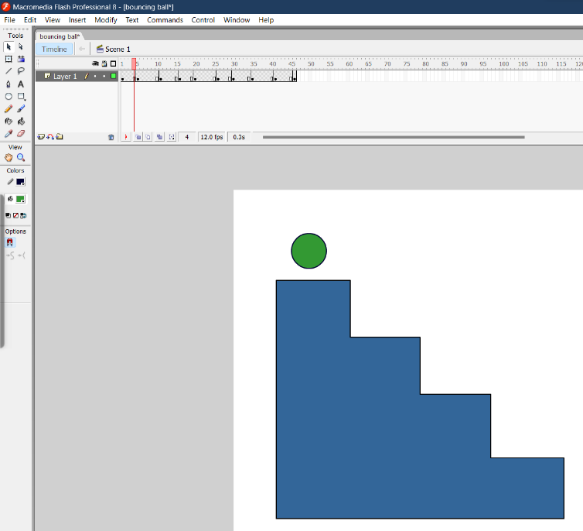
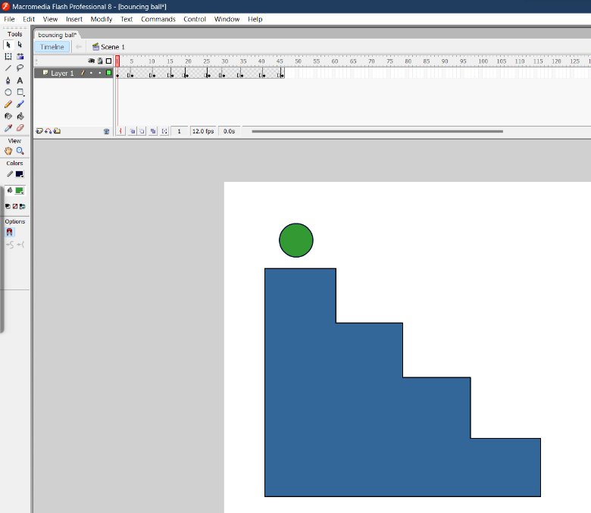
Bouncing ball by frame-by-frame animation in Macromedia Flash Professional 8

